**Transformer Oil Market to Surge, Projected to Reach USD 11,047.2 million by 2035 Amid Rising Energy Demand and Grid Expansion | Study by Future Market Insights, Inc.**

*With the rapid growth of digitalization, cloud computing, and the Internet of Things (IoT), there has been a significant expansion of data centers in the United States. These data centers house several servers and electronic equipment that require transformers for power distribution.*

**NEWARK, Del:** The global [Transformer Oil Market](https://www.futuremarketinsights.com/reports/transformer-oil-market) is expected to witness substantial growth over the next decade, expanding from a market size of USD 4,752.9 million in 2025 to USD 11,047.2 million by 2035. This impressive expansion is driven by increasing global energy consumption and the growing demand for electrical grid infrastructure development, particularly in emerging economies.

Transformer oil is an essential component for ensuring efficient power transmission and the smooth operation of transformers. With the rapid industrialization and urbanization in several regions, power demands are rising, consequently fueling the transformer oil market. Additionally, the transition towards renewable energy is pushing the demand for large-scale transformers, further supporting market growth.

Rising investments in electrical infrastructure by both private and public sector companies are contributing to the [demand for transformer oils](https://www.fmiblog.com/2024/07/24/transformer-oil-market-to-surpass-usd-10140-8-million-by-2033-driven-by-rising-demand-for-grid-modernization-and-renewable-energy-integration/). In regions like Asia-Pacific, where nations are focusing on upgrading their energy infrastructure, transformer oil is in high demand to ensure reliable electricity distribution.

Moreover, technological advancements such as biodegradable transformer oils and the increasing focus on environmentally sustainable solutions are expected to open up new opportunities for market players. This has led to the development of innovative, high-performance oil products catering to the specific needs of modern transformers.

**Drivers and Opportunities**

Several key factors are driving the growth of the transformer oil market. A primary driver is the expanding global [power grid](https://www.futuremarketinsights.com/reports/power-grid-market) infrastructure, which is supported by both private and government investments in emerging economies. The growing emphasis on renewable energy sources and clean energy initiatives is further boosting the demand for transformer oil. Additionally, the shift towards smart grids and advanced distribution systems has created a surge in transformer demand, fueling market expansion.

Opportunities in the market are also being driven by technological innovations, such as the development of biodegradable and high-performance synthetic oils that meet stringent environmental regulations. As environmental concerns grow, companies are looking to develop eco-friendly products that will cater to the increasing demand for sustainable transformer solutions.

***Driven by the global shift towards renewable energy and smart grid infrastructure, the transformer oil market is set for robust growth, with eco-friendly innovations and rising investments in power infrastructure paving the way for future opportunities,”*-** says [Nikhil Kaitwade](https://www.linkedin.com/in/nikhil-kaitwade-a45b7313/), Associate Vice President at Future Market Insights (FMI)

**Key Takeaways from Market Study:**

* The global transformer oil market is projected to reach USD 11,047.2 million by 2035.
* Market size in 2025 stands at USD 4,752.9 million, growing at a CAGR of 8.8% from 2024 to 2034.
* Increasing demand for renewable energy infrastructure is a significant growth driver.
* Technological advancements in eco-friendly oils present growth opportunities for market players.
* Asia-Pacific is expected to dominate the market due to rapid industrialization and energy infrastructure upgrades.

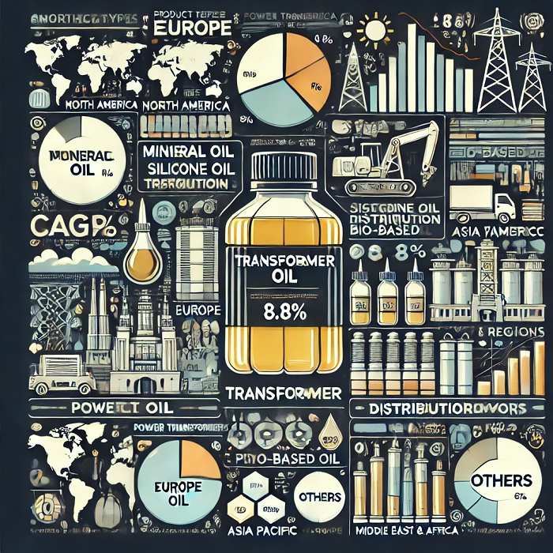

**Component Insights**

Transformer oil is available in various forms, including mineral oil, silicone oil, and bio-based oil. Mineral oil dominates the market due to its cost-effectiveness and wide usage in power transformers. However, the demand for bio-based oils is steadily increasing, driven by rising environmental concerns and regulations mandating the use of eco-friendly alternatives.

Silicone oil, known for its excellent thermal properties and oxidation resistance, is also gaining traction, especially in specialized applications that require enhanced performance and longevity.

**Market's Prime Determinants of Growth, Trends, and Opportunities**

The primary growth drivers for the transformer oil market are the increasing demand for electrical grid infrastructure and the rising global energy consumption. Additionally, emerging trends such as smart grid deployment, increased use of renewable energy, and stringent environmental regulations are pushing the development of advanced, eco-friendly transformer oils. The growing adoption of digitalization in power infrastructure and the need for energy-efficient solutions also present opportunities for market growth.

Technological advancements, particularly in biodegradable and bio-based transformer oils, offer significant potential for innovation. These oils help mitigate environmental impact, aligning with government policies for reducing carbon footprints, creating further growth prospects.

**Key Companies & Market Share Insights**

The transformer oil market is highly competitive, with key players such as **Royal Dutch Shell; Exxon Mobil Corporation; Repsol; Nynas AB; Sinopec Lubricant Company; APAR Industries; Petro China Company Limited; Savita Oil Technologies Limited; Chevron Corporation; M&I Materials Limited; Petro-Canada; Gandhar Oil; Lubrita; Phillips 66 Company; Ergon, Inc.** holding significant market shares. These companies are focusing on product innovation and expanding their distribution networks to cater to the growing demand for transformer oils. Additionally, strategic partnerships and acquisitions are playing a crucial role in strengthening their market positions.

**Growth Drivers**

1. Increasing investments in power infrastructure development across emerging markets.
2. The rising demand for renewable energy generation and distribution.
3. Technological advancements in eco-friendly and high-performance transformer oils.
4. Regulatory pressures for using sustainable and biodegradable transformer oils.

**Transformer Oil Market Segmentation by Category**

**By Oil Type:**

* Mineral Oil
  + Paraffinic
  + Naphthenic
* Silicone Oil
* Bio-based Oil

**By End-use:**

* Transmission and Distribution
* Power Generation
  + Coal
  + Nuclear Plants
  + Wind Energy
  + Solar
  + Others
* Railways & Metros

**By Application:**

* Transformer
* Switchgear
* Reactor

**By Transformer Capacities:**

* LV Transformers
  + Up to 50 kva
  + 50 to 100 kva
  + 100 to 500 kva
  + Above 500 kva
* MV Transformers
  + Up to 1 Mva
  + 1 to 5 Mva
  + Above 5 Mva
* HV Transformers
  + Up to 10 Mva
  + 10 to 50 Mva
  + 50 to 100 Mva
  + 100 to 500 Mva
  + Above 500 Mva
* Traction Transformer
  + Up to 5 Mva
  + 5 to 10 Mva
  + 10 to 15 Mva

**By Region:**

* North America
* Latin America
* Europe
* East Asia
* South Asia Pacific
* Middle East and Africa

**Old Source:** [**Transformer Oil Market to Reach USD 8,703.2 Million by 2032 Owing to its Usage in Diverse Industries to Offer Fault-Free Operations | Future Market Insights, Inc.**](https://www.globenewswire.com/en/news-release/2023/03/16/2628921/0/en/Transformer-Oil-Market-to-Reach-US-8-703-2-Million-by-2032-Owing-to-its-Usage-in-Diverse-Industries-to-Offer-Fault-Free-Operations-Future-Market-Insights-Inc.html)

**Author by:**

[Nikhil Kaitwade](https://www.linkedin.com/in/nikhil-kaitwade-a45b7313/) (Associate Vice President at Future Market Insights, Inc.) has over a decade of experience in market research and business consulting. He has successfully delivered 1500+ client assignments, predominantly in Automotive, Chemicals, Industrial Equipment, Oil & Gas, and Service industries.

His core competency circles around developing research methodology, creating a unique analysis framework, statistical data models for pricing analysis, competition mapping, and market feasibility analysis. His expertise also extends wide and beyond analysis, advising clients on identifying growth potential in established and niche market segments, investment/divestment decisions, and market entry decision-making.

Nikhil holds an MBA degree in Marketing and IT and a Graduate in Mechanical Engineering. Nikhil has authored several publications and quoted in journals like EMS Now, EPR Magazine, and EE Times.

**Explore FMI's Extensive Coverage in the Chemicals & Materials Domain:**

[India retail mineral turpentine oil industry size](https://www.futuremarketinsights.com/reports/india-retail-mineral-turpentine-oil-market) reached USD 49.1 billion in 2025. Over the forecast period, demand in the country is anticipated to rise at 9.4% CAGR.

Over the forecast period, [soft magnetic composite demand](https://www.futuremarketinsights.com/reports/soft-magnetic-composites-market) is anticipated to rise at a 9.3% CAGR. Total market value is predicted to increase from USD 44,459.0 million in 2025 to USD 1,08,392.0 million by 2035.

Over the forecast period, global [iron ore pellet demand](https://www.futuremarketinsights.com/reports/iron-ore-pellet-market) is anticipated to rise at a 7.9% CAGR. Total market value is predicted to increase from USD 66,503.9 million in 2025 to USD 141,988.8 million in 2035.

The [refrigeration oil market size](https://www.futuremarketinsights.com/reports/refrigeration-oil-market) is projected to be valued at USD 1,425.9 million in 2025 and is expected to rise to USD 2,332.9 million by 2035.

[Demand for cold rolling oils and lubricants](https://www.futuremarketinsights.com/reports/cold-rolling-oils-lubricants-market) is predicted to rise at a CAGR of 5.6% and end up with an estimated market valuation of USD 18.2 Billion by 2028.

Future Market Insights (FMI) has forecasted the [Oilfield Production Chemicals market](https://www.futuremarketinsights.com/reports/oilfield-production-chemicals-market) to grow with a year on year growth of 4.0% in 2022 reaching a value of about USD 3,021.8 Million by 2022 end.

Over the forecast period, global [demand for compressor oils](https://www.futuremarketinsights.com/reports/compressor-oil-market) is poised to rise at 5.4% CAGR. Total market value is predicted to grow from USD 6,513.7 million in 2024 to USD 11,001.4 million in 2034.

The global [oilfield chemicals market](https://www.futuremarketinsights.com/reports/oilfield-chemical-market) is likely to attain a valuation of USD 28534.31 million in 2025 and is expected to reach USD 44580 million by 2035, trailing a CAGR of 4.5% during the forecast period.

The global [oil and gas pipeline coating market size and share](https://www.futuremarketinsights.com/reports/oil-and-gas-pipeline-coatings-market) will be pushed through the forecasted period at a moderate CAGR of 5.4%.

The progress path for the [global waste-derived pyrolysis oil market](https://www.futuremarketinsights.com/reports/waste-derived-pyrolysis-oil-market) is at a moderate CAGR of 5.1%, with an estimated market size of USD 571.8 million by 2034, elevating it from USD 347.6 million in 2024.

**About the Chemical & Material Division at Future Market Insights**

The chemical & material team at Future Market Insights offers expert analysis, time-efficient research, and strategic recommendations with the objective to provide authentic insights and accurate results to help clients worldwide. With a repertoire of over 100+ reports and 1 billion+ data points, the team has been analyzing the industry lucidly in 50+ countries for over a decade. The team provides a brief analysis of key trends including competitive landscape, profit margin, and research development efforts.

**About Future Market Insights (FMI)**

Future Market Insights (FMI) is a leading provider of market intelligence and consulting services, serving clients in over 150 countries. FMI is headquartered in Dubai and has delivery centers in the United Kingdom, the United States, and India. FMI's latest market research reports and industry analysis helps businesses navigate challenges and make critical decisions with confidence and clarity amidst breakneck competition. Our customized and syndicated market research reports deliver actionable insights that drive sustainable growth. A team of expert-led analysts at FMI continuously tracks emerging trends and events in a broad range of industries to ensure that our clients prepare for the evolving needs of their consumers.

Join us as we commemorate 10 years of delivering trusted market insights. Reflecting on a decade of achievements, we continue to lead with integrity, innovation, and expertise.

**Contact Us**

Future Market Insights Inc.

Christiana Corporate, 200 Continental Drive,  
Suite 401, Newark, Delaware - 19713, USA  
T: +1-845-579-5705  
**For Sales Enquiries:**[sales@futuremarketinsights.com](mailto:sales@futuremarketinsights.com) **Website:** [https://www.futuremarketinsights.com](https://www.futuremarketinsights.com/)  
[LinkedIn](https://www.linkedin.com/company/future-market-insights/)| [Twitter](https://twitter.com/FMI_Research)| [Blogs](https://www.futuremarketinsights.com/blogs) | [YouTube](https://www.youtube.com/@Futuremarketinsights)